FOR IMMEDIATE RELEASE
Press Contact: Pat Griffin pat@nellandmary.com / (503) 683-1723

Nell & Mary Launches 31-Piece Handcrafted Housewares 2014 Spring/Summer Collection
New products include full-length chambray kitchen aprons; chambray napkins; new prints for tea towels,
pouches, throw pillows, and tote bags
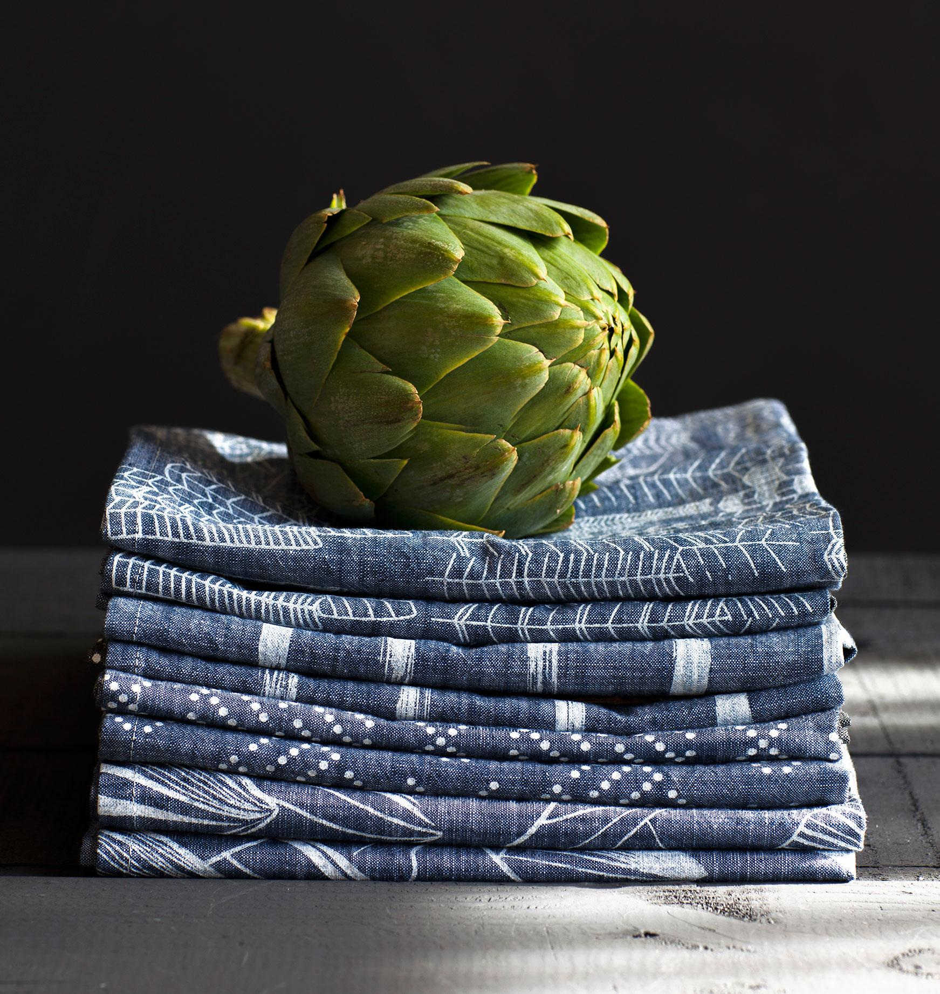
April 17, 2014, Portland, OR: Today, housewares crafters Nell & Mary unveiled their 2014 Spring/Summer Collection. It features 31 brand new pieces including full-length, 100% cotton yarn-dyed chambray printed kitchen aprons; printed chambray napkins; and seven new designs screen-printed by hand onto their signature tea towels, pouches, throw pillows and tote bags.
Made from organic, American-milled cotton; designed, sewn and screen-printed in one-of-a-kind designs by hand; and prices ranging from $20 to $85 USD, the Nell & Mary Spring/Summer 2014 Collection is available at boutiques including Lawson Fenning in Los Angeles, SFMOMA in San Francisco, Bobby Berk Home in New York City, West Elm in Portland, and at www.nellandmary.com.

The Nell & Mary Spring/Summer 2014 Collection debuts seven new prints including natural brush strokes, geometric dot textiles, abstract city and mountain-scapes, and artichokes and mangos. The new prints were designed by Krista Stovel and Avery Boom, printed by hand, and inspired by vintage Scandinavian and Japanese textiles, the Pacific Northwest landscape, and the designers’ own favorite foods.

“We’re as committed to practicality as we are to design,” said co-founder Leah Stovel. “Life can get hectic, and if we get ambushed by an impromptu dinner party, ironing aprons and napkins isn’t going to top our list. Nell & Mary’s new elegant chambray requires none of that maintenance.”
“There’s no denying the glory of wiping your mouth with a hand-sewn, made-in-the-USA chambray napkin. Cornering the handmade/hipster market: Nell & Mary, a charming Oregon design studio cranking out seriously sweet home accents. Their latest collection is flush with utilitarian materials and built to last.” --Emily Fiffer, Daily Candy
“[Nell & Mary’s tea towels] are versatile. They're inexpensive. And they're handmade, by local artisans to boot.” --Los Angeles Times.
To download high-res photos of the Nell & Mary Spring/Summer 2014 Collection, click here:
http://www.nellandmary.com/pages/pressroom
For interviews and product samples, contact publicist Pat Griffin:
pat@nellandmary.com / (503) 860-0672
Founded in 2012 by Krista Stovel, Leah Stovel Bloom and Avery Bloom, Nell & Mary is an independent housewares crafter committed to sustainable practices throughout its business. They source American-made fabrics, print with the most eco inks available on the market, and design and produce their products in-house from start to finish.
Nell & Mary is located at 1420 SE Water Avenue, Portland, OR 97214 USA
Telephone: +1 (503) 860-0672
http://www.nellandmary.com/

###

